|  |  |
| --- | --- |
| Plan of Action  Honeyjar and Malware studies | Abstract  This document describes the background of this project, as well as being a clear summary of expected actions and responsibilities for all project members involved. |

# Version management

|  |  |  |  |
| --- | --- | --- | --- |
| **Version** | **Author** | **Date** | **Comments** |
| 0.1 | Morcel | 20-02-2018 | Added chapters |
| 0.2 | Alexander | 21-02-2018 | Added front page, as well as further defining of the problem definition |
|  |  |  |  |
|  |  |  |  |
|  |  |  |  |

Table of Contents

1. Background 5

2. Subject of research 6

3. Goal and Problem Definition 7

3.1. Problem definition 7

3.2. Goal 7

3.3. End-results 7

4. Theoretical framework 8

5. Tools of Research 9

6. Organization 10

7. Planning 11

8. Costs 12

9. Feasibility and risks 13

# Background

The current project group consists of nine people coming from four different universities.

|  |  |
| --- | --- |
| University | Project member(s) |
| Saxion (NL) | Alexander Pluimers  Morcel el Ouahbi |
| AAU (DK) | Jacob Veljin Jensen  Daniel Britze  Magnus Stensli  Robert Nielsen  Peter Moller |
| AGU (TR) | Ahmet Turkmen |
| UTP (PL) | Anna Switala |

The people mentioned are all equal and have the same obligations. The group works together and makes sure everyone is able to do their part in the project. Since everything is intertwined it is important the group keep communicating and gives each other feedback where possible.

The project originated from the University of Aalborg (AAU). There had been a couple of projects prior to this one which focued on Honeypot systems (Jens mailen, hoeveel projecten zijn er al geweest en ging dit alleen over een honeypot system of ging di took over een android based system?)

Everyone except for the people from AAU are new to this project. These project members from AAU have worked on this project half a year prior to the rest and have made a basic simple android based honeypot system.

Their assignment was to improve cybersecurity. They took their research to Android phones since according to their research, people store a lot of sensitive data on their smartphones and cybersecurity on smartphones isn’t deemed urgent by the masses at this point in time.

Saxion has brought two business IT students to the project. Their job is to create a system that is appealing for the market. In what form can this be a product that will be appealing to a potential customer? Other tasks that these students are specialized in is:

* Different kinds of modeling, think of BPMN, Database models, Data Flow Diagrams
* Translating customer needs into IT solutions
* Experience in working within a multidisciplinary group
* Facilitating the team where needed

(AAU?)

(AGU?)

(UTP?)

NOT FINISHED

# Problem Definition

In this paragraph the group will describe what the reason for the project is as well as the desired end result when the project is finished. We will do this with the help of research questions. These questions will help us divide the project into smaller chunks. When all the sub questions have been answered you automatically answered the main issue.

## Statistics

Companies as well as regular consumers have a lot of sensitive data stored on their smartphones, for example (but not limited to):

* Credit card data
* Compromising photos
* Passwords
* E-mails
* Customer data

This in itself is worrisome, however the popularity of smartphones is rising as well. At this point in time smartphones outsell PC’s. Computers have been susceptible to malware since they were first introduced to the market, however it seems that Android phones, while vastly gaining popularity over PC’s, are still relatively under protected to Malware attacks. This is represented in the graph below, which is derived from a survey done by the project members from AAU. (BRON HIERR)

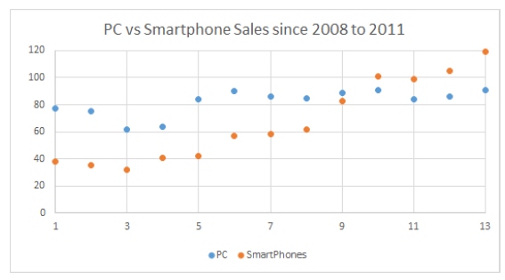

To exploit the fact that the market hasn’t really focused on security on Android phones yet, the project members from AAU created a basic Honeypot system.

A Honeypot, as to be derived from its name, is a virtual machine that emulates a system, in our case an Android Phone, presenting it in such a way that it becomes interesting for malware to attack. This Honeypot system in its current state is still very basic and needs improving.

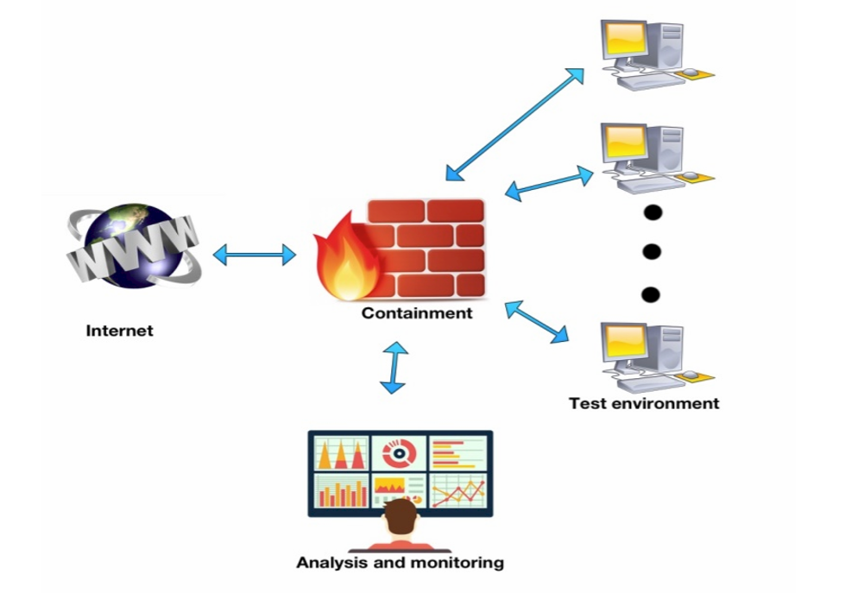AAU has created a figure of how the honeypot system should work, this is illustrated in the following figure.

The three computers in the example will be running an emulated version of Android, making the emulation seem as realistic as possible, i.e. emulating human behavior. Once these systems are infected through the internet, the malware will be contained, and analyzed to determine what the category of the Malware is.

## Goal

The goal of this Honeyjar is to provide intelligence on the nature of the Malware that is captured and contained in the quarantine. Furthermore, based on the intelligence that is gained in containment, the Honeyjar algorithm has to show improvement in recognizing Malware.

## End results

At the end of this project the following will be finished and accomplished:

1. A functional Honeyjar system that shows improvement in recognizing Malware through Machine Learning
2. A Business Plan to describe the Business aspects of the Honeyjar and how to make the system profitable
3. At least 1 Android Virtual Machine that functions as bait for Malware

# Project Boundaries

The following paragraph is meant to be clear on what the project won’t deliver. To be very transparent on what we will and won’t deliver.

# Theoretical framework

Volgende week, Misschien?

# Tools of Research

In this chapter will be described which tools the project group will use to gain the information necessary to conduct the project.

## Desk research

As all project members are located in different countries, some necessary research has to be done by collecting information through the internet, books, and other sources. This includes research such as (but not limited to):

* Tutorials on Virtual Machines, servers, Android, etc.
* Manuals for the server
* Documents describing Honeyjar systems
* Articles
* Forums
* Troubleshooting

## Field research

For information that needs to be actual, field research will be performed. Information will be collected through interviews with companies focused on security, as well as other relevant people which are to be selected during the course of this project.

Through the conducting of interviews information will be collected that will be summarized through axial coding, making the information usable and measurable. This information can then be put into a program like Excel to showcase which results of the interviews are the most recurring, thus giving the project group insight in what is considered relevant.

## Sharing of knowledge

To make sure everyone in the group is up-to-date with the progress that’s being made, during every virtual meeting all project members share what they have been researching the week prior. This keeps every project member informed, and allows for room for discussion.

# Organization

In this paragraph the project group is defined and elaborated upon.

As said in background the project group consists of nine different people spread across four different universities. There will also be a supervisor which is closely involved with the project. On top of that has every university a teacher that will guide the student throughout the process.

|  |  |  |
| --- | --- | --- |
| **Function/role** | **Name** | **Tasks** |
| Supervisor | Jens Myrup Pedersen | Supervising/guiding the whole group during the project. |
| Supervisor | Etto Salomons | Supervising and guiding the business students during the project. |
| (AGU Teacher) |  |  |
| (UTP Teacher) |  |  |
| Programmer | Jacob Vejlin Jensen | Improving the Honeypot system |
| Programmer | Peter Bolstad Møller | Improving the Honeypot system |
| Programmer | Daniel Britze | Improving the Honeypot system |
| Programmer | Robert Nielsen | Improving the Honeypot system |
| Programmer | Magnus Stensli | Improving the Honeypot system |
| Programmer/Networking | Ahmet Türkmen | Improving the Honeypot system and doing network analyses |
| Networking | Anna Switala | Improving the containment zone of the Honeypot |
| Business IT | Alexander Pluimers | Creating a vision as well as a business plan for the product. |
| Business IT | Morcel el Ouahbi | Creating a vision as well as a business plan for the product. |

The following table contains contact information from everyone who is involved during the project.

|  |  |  |
| --- | --- | --- |
| **Name** | **Phone number** | **Mail adres** |
| Jens Myrup Pedersen | +45 99 40 87 71 | jens@es.aau.dk |
| Etto Salomons | +31 6 22 49 06 77 | [e.l.salomons@saxion.nl](mailto:e.l.salomons@saxion.nl) |
| AGU Teacher |  |  |
| UTP Teacher |  |  |
| Jacob Vejlin Jensen | +45 25 14 09 90 | [jvje17@student.aau.dk](mailto:jvje17@student.aau.dk) |
| Peter Bolstad Møller | +45 26 95 30 33 | [pmolle17@student.aau.dk](mailto:pmolle17@student.aau.dk) |
| Daniel Britze | +45 28 64 31 17 | [dbritz17@student.aau.dk](mailto:dbritz17@student.aau.dk) |
| Robert Nielsen | +45 28 76 82 75 | [rnni17@student.aau.dk](mailto:rnni17@student.aau.dk) |
| Magnus Stensli | +45 51 96 45 60 | [mstns17@student.aau.dk](mailto:mstns17@student.aau.dk) |
| Ahmet Türkmen | +90 541 204 37 48 | [f.ahmet.turkmen@icloud.com](mailto:f.ahmet.turkmen@icloud.com) |
| Anna Switala | +48 782 33 55 97 | [annswi004@utp.edu.pl](mailto:annswi004@utp.edu.pl) |
| Alexander Pluimers | +31 6 44 16 33 38 | [314831@student.saxion.nl](mailto:314831@student.saxion.nl) |
| Morcel el Ouahbi | +31 6 21 35 29 90 | [423819@student.saxion.nl](mailto:423819@student.saxion.nl) |

# Costs

(Waiting for feedback from Jens)

# Feasability and risks

## Feasability

Feasability describes what the project needs to function, i.e. money, infrastructure, materials, expertise, and time.

### Money

For this project money is not an issue as all intercultural meetings are accounted for by EPIC.

### Infrastructure

One of the pillars of this project is that it’s intercultural, so project members will work together from their home countries. There are weekly online meetings where progress is discussed. Other than that there are plans to meet in a city somewhere in Europe at least one more time during the project.

### Materials

For setting up the server on which the Honeyjar is hosted, the University of Aalborg provides free server space. Other than that all project members will be using software that is either freeware or accounted for through a student license.

### Expertise

As the project group consists of 9 members, there are a different expertises; business, networking, and programming. These different expertises are useful for providing different approaches to the project.

### Time

All project members are expected to work on the project every day, ranging from a few hours every day to full-time. Even though the project group is the largest among the EPIC groups, the project is big and ambitious, so maximal effort is required.

## Risks

### Different deadlines

As all project members work on this project in a different year and/or in a different format (i.e. the Business project members are doing this project for their Minor studies, while the Danish group is doing this for their first year of school), the deadlines for each project member differ. This opens up the possibility that project members are going to follow their own agenda as opposed to working towards a common deadline as a team. To prevent this, the group created a planning with each deadline carefully noted.

### Miscommunication

Due to the intercultural nature of this project, we expect there to be some miscommunication and cultural differences. We try to avoid this by setting up ground rules.

# Appendices

## C:\Users\Morcel\Dropbox\HoneyJar Business\Business\Planning.pngAppendix I: Planning